**Co-Sponsors**

**District 1, 5, & 9**

**Come One, Come All**

**It’s Time to Register!**

**Register under the “Events” tab:**

[**www.mnadistrict2.org**](http://www.mnadistrict2.org)

**6.5 Contact Hours**

**Submitted for Review**

Sponsored by Maryland Nurses Association



**Posters & Oral Presentations:**

**National Institutes of Health**

**Maryland Higher Education Commission**

**Maryland Board of Nursing**

**Maryland Schools of Nursing & Hospitals**

**American Academy of Nursing’s Living Legends**

**Historic Expert Panel** **on:** **Mentoring & the Future of Nursing**

[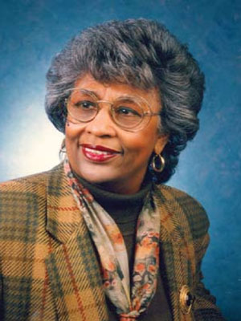](https://www.google.com/url?sa=i&rct=j&q=&esrc=s&source=images&cd=&cad=rja&uact=8&ved=0ahUKEwi-jOe8u_7SAhWCbSYKHWI1D0IQjRwIBw&url=https://aan.memberclicks.net/index.php?option%3Dcom_content%26view%3Dfrontpage%26limitstart%3D20&bvm=bv.151325232,d.amc&psig=AFQjCNEfDDcZzmiTHldvp_WZTua1HPuBDA&ust=1490971350408559) A person in a red shirt

**Bernadine Lacey Catherine Georges Barbara Nichols Diane Billings**

**EdD, RN, FAAN EdD, RN, FAAN DNSc (hon), MS, RN FAAN EdD, RN, FAAN**

Former Dean & AARP Board of Directors ANA Past President Professor Emeritus

Presidential Advisor Indiana University

Keynote Address:

Nursing in the 21st Century

**Barbara Nichols, DNSc (hon), MS, RN, FAAN**

Special Presentation:

Certified Nurse Educator (CNE) & Best Practices

**Diane Billings EdD, RN, FAAN**

Standardized Testing & Strategies to Promote Student Success

**Panel Discussion with Maryland Educators**

April 18, 2020

8:00 a.m. – 4:30 p.m.

Maritime Institute, Building #3 North Academic Wing

Linthicum, Maryland

**“The Year of the Nurse”**

# 2020 Nursing Education Summit

